ETHEREUM

Ethereum :-
Ethereum is basically block chain where you can write programing code. If that programing code represented any type of contract we will call as smart contract.

Smart Contract :-
Smart contract like a code and it’s writen in solidity langauges on Reminx Ide. Solidity langauges similler to java script langauages.

Ethereum smart contract is a combination code logic and data store in the block chain and exceute by the Ethereum virtual machine or evm. What is evm machine excute. It’s evm bytecode but as a developer. You have not code smart code in evm bytecode. So we useing some high-level programimg languages that be use develop smart contact and that can be compile down into evm bytecode incuding byper, bamboo, solidity.

Solidity widely use to deploy smart contact.

DAPP : - Writen in python we need to deploy that DAAP able to Communicate through DAAP
to ethereum network

Web3 : it’s python libarary which help to communicate with ethereum network. Ethereum use JSONRPC Which is protocal lang. That allow to DAAP commuincate to ethereum network

Geth: - Geth or G0-Ethereum is the command line interface that allows you to run and operate a full Ethereum node. Geth is implemented in Go and allow you to mine block, to generate Ether, to deploy and interact with smart contracts, to transfer funds, to inspect block history, to create account and so on and so forth, Geth can be used to connect to the public Ethereum network also called main net,or to create your own private network for developmenet
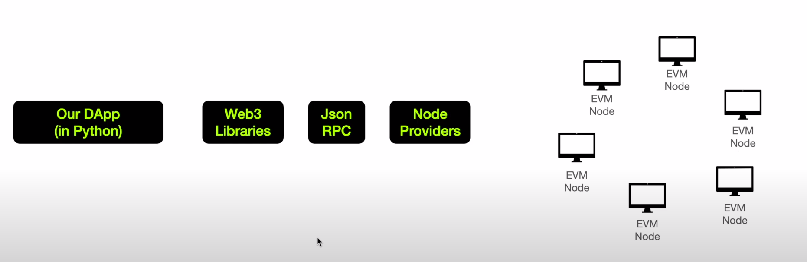

Process:-
need to exceute Ethereum virtual machine so we need to first install Ethereum innside docker and
run as a server. After start server deploy samart contract on Ethereum server

Note : developer write code in solidity then compile and convert into bytecode then transfer into Evm Network

sudo apt-get update
sudo apt-get upgrade
apt install software-properties-commom
add-apt-repository -y ppa:ethereum/ethereum
apt update
apt install ethereum
geth version

Step 2 :- Start Second Terminal And create new private Node on EVM Network

Create Private Node: -

puppeth # cmd use for create your genesis file “chainblock.json”

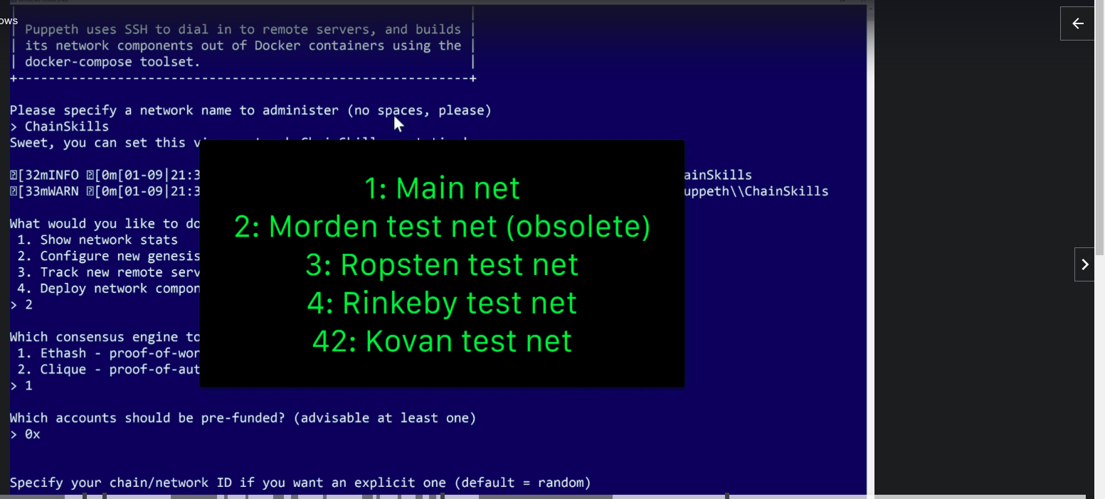

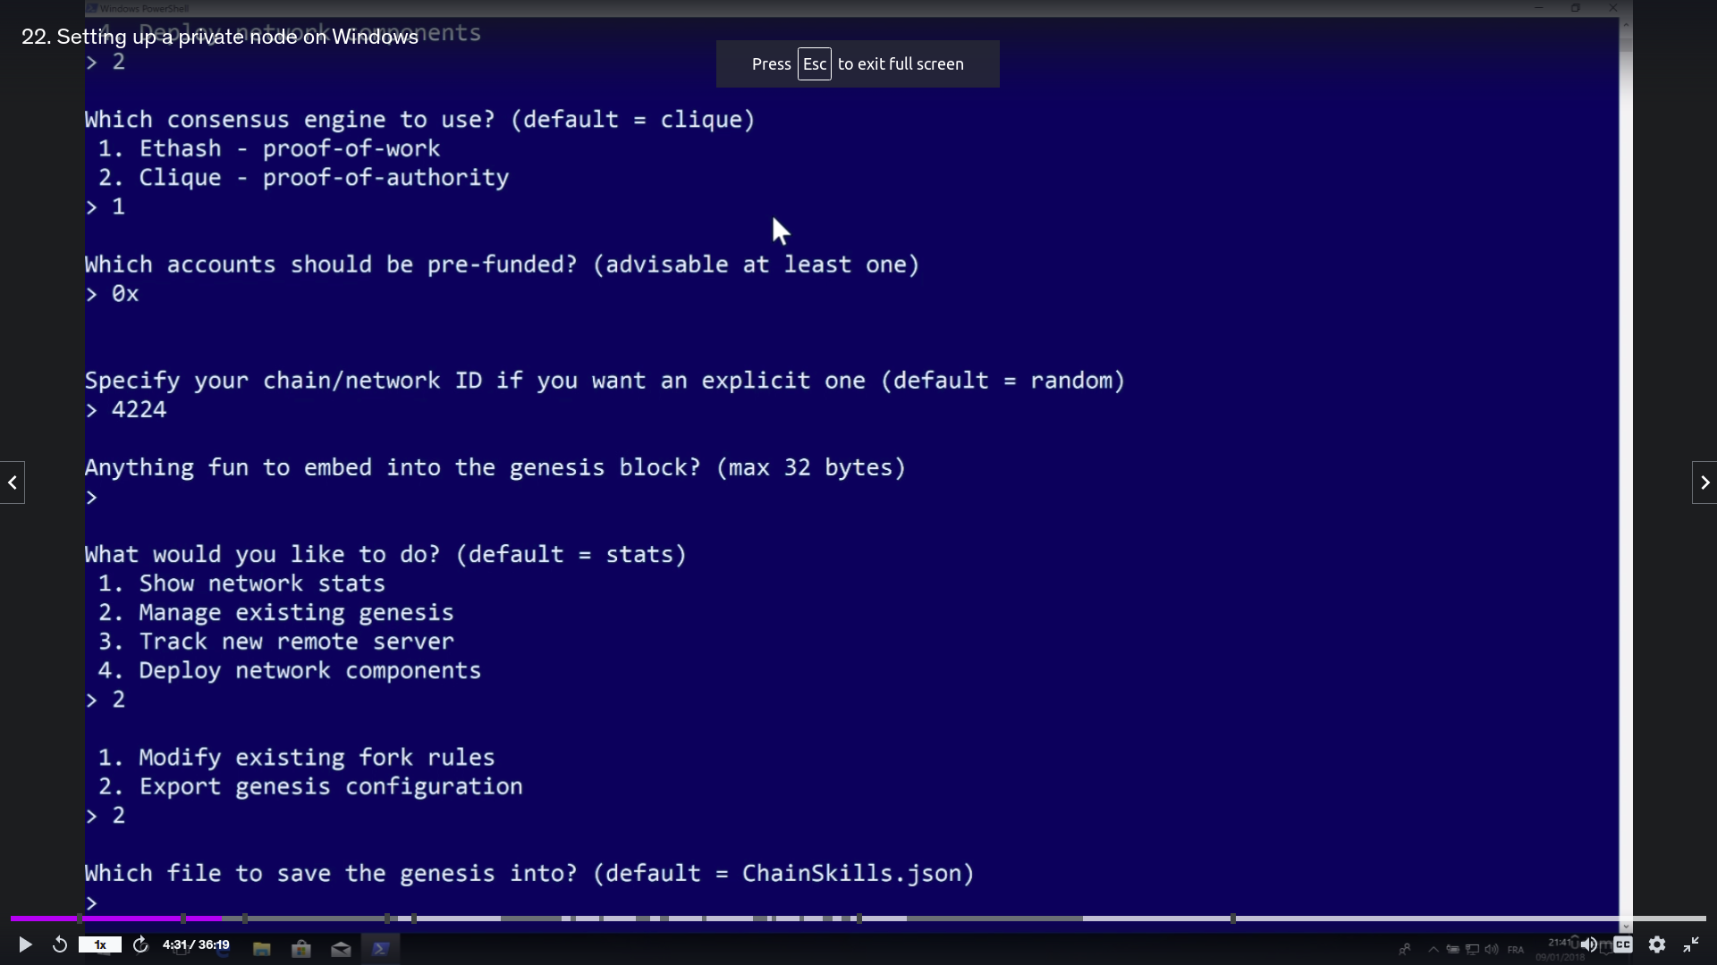

geth --datadir . init chainblock.json “to initialize a node”
geth --datadir . account new
geth --datadir . account list

create ./start.sh file to start ethereum server
geth --allow-insecure-unlock --networkid 4224 --mine --datadir . --nodiscover --http --http.port "8545" --port "30303" --http.corsdomain '*' --nat "any" --http.api personal,eth,net,web3 --unlock 0 --password password.sec --ipcpath "~/.ethereum/geth.ipc" --syncmode "full"

create a password.sec file and save your accout password inside password.sec file

chmod +x start.sh
./start.sh

Start Ethereum Server

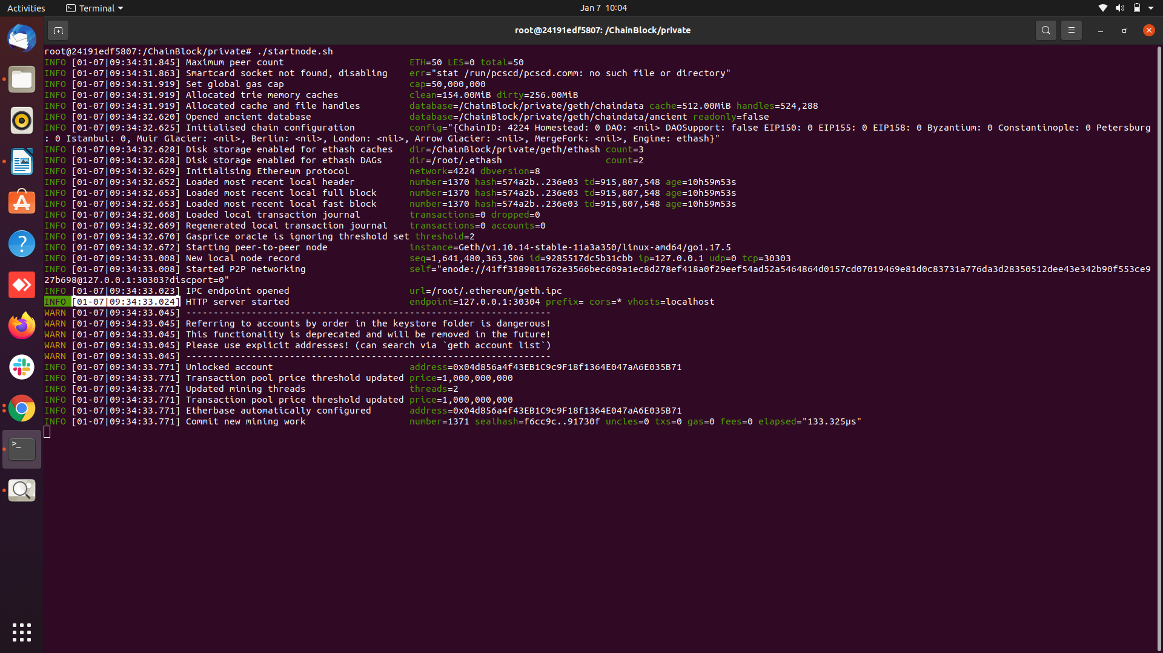

NodeJs and NPM: - NODEJS is a server-side javaScript platform to create application that will interact with our Ethereum node. So we need to install NodeJS and NPM that is required to set up most of the tools and libraries required to develop for Ethereum.
Check :- node -v ,npm -v
check : NODEJs version at least 8 and NPM is at least 5
https://nodejs.org/en/download/package-manager/

sudo apt install curl
apt-get install nodejs
apt-get install npm
node -v or node –version
npm -v or npm –version

Enter Ethereum Block Chain : geth attach
CMD:

eth.accounts
eth.coinbase
web3.fromWei(eth.getBalance(eth.coinbase), "ether")
web3.fromWei(eth.getBalance(eth.accounts[0]), "ether")
miner.stop()
miner.start()
null
net.version
personal.unlockAccount(eth.accounts[1], "pass123" ,300)
personal.unlockAccount(eth.accounts[1])
web3.fromWei(eth.getBalance(eth.accounts[1]),"ether")
0
> eth.sendTransaction({from: eth.coinbase, to: eth.accounts[1], value: web3.toWei(10, "ether")})
"0xfc139b97bc25a2eae9f6d945bd8cea16892cc036539edf127808cdebbb8daa9f"
> web3.fromWei(eth.getBalance(eth.accounts[1]),"ether")

Reference Video link:- https://youtu.be/A5V2jdLi5mI

